**Build A Flask Application**

Duration: 0.5 Hrs

Skill Tags:

**Step 1:** Load the required packages

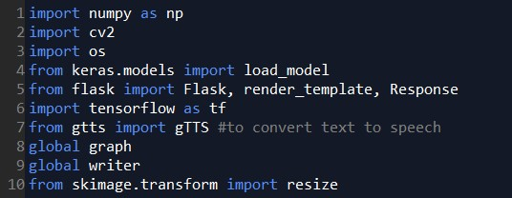

**Step 2:** Initialize graph, load the model, initialize the flask app and load the video

Graph element is required to work with tensorflow. So, graph element is created explicitly.

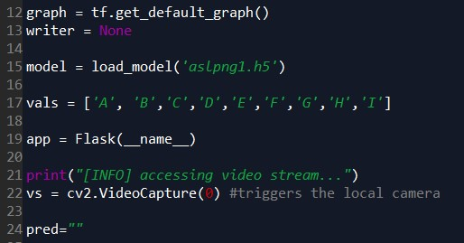

**Step 3:** Configure the home page



